I was thinking about chromatic aberration in general and what other things also resemble it. Two things came to mind:

**1. Jelly Fish and Star Fish**

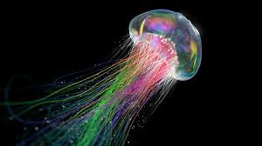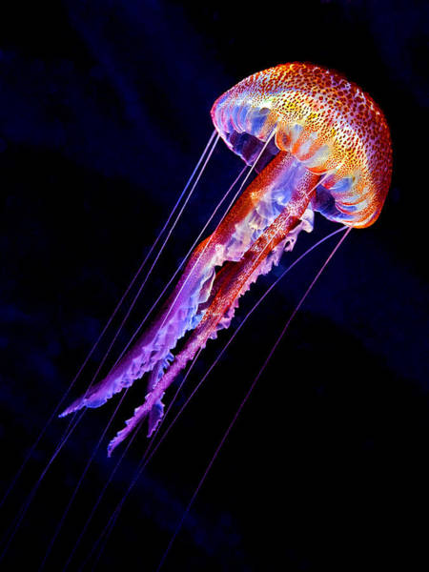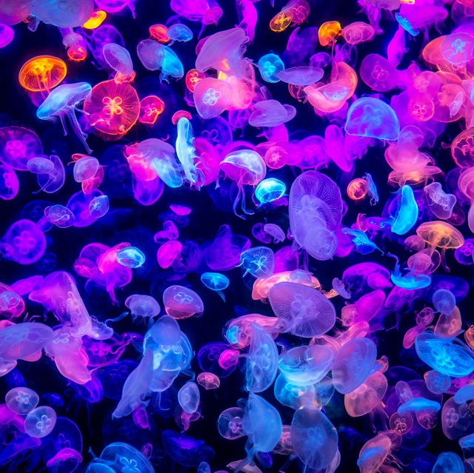

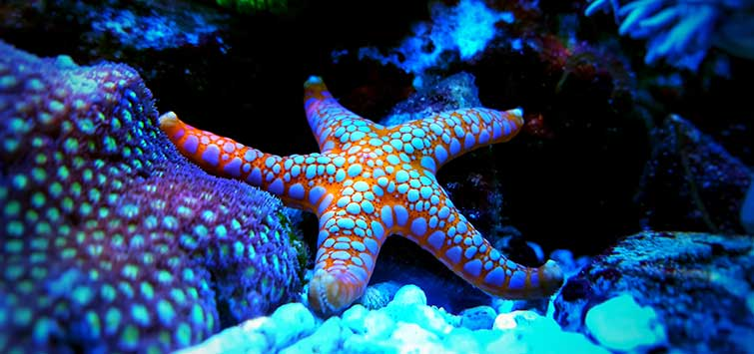

And I thought the tentacles reminded me of stream graphs, which are common in D3

**2. CRT/LED pixels in closeup view**

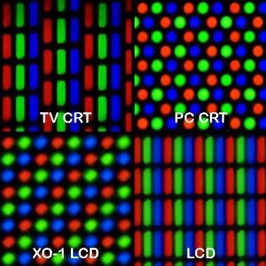 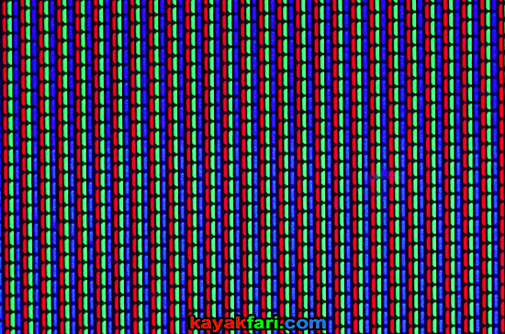 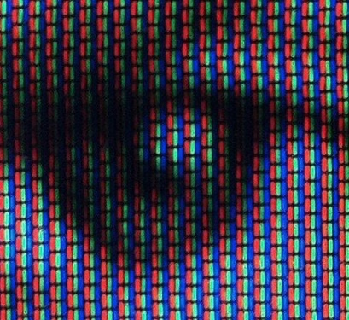

So, I started experimenting with putting some design elements together:

* Bubble graph

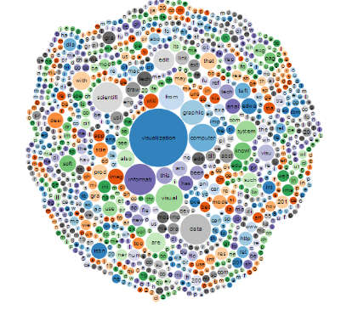

* Stream graphs

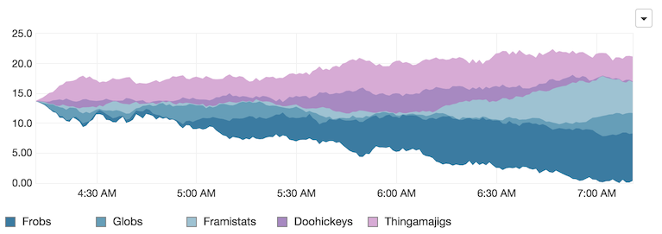

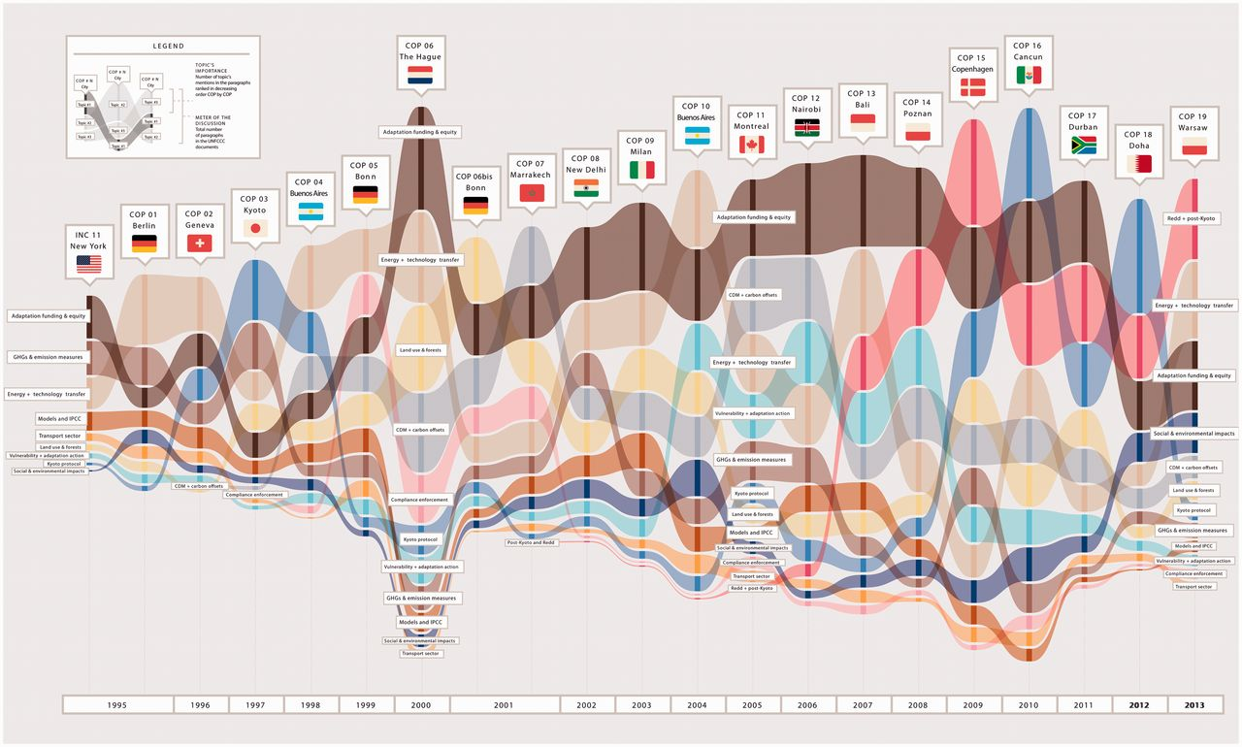

* Simple line graphs

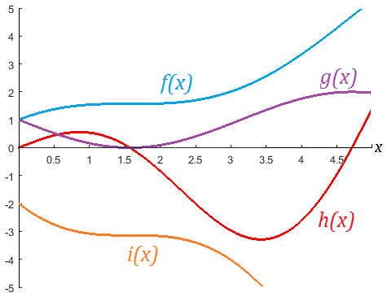

* Pixel textures

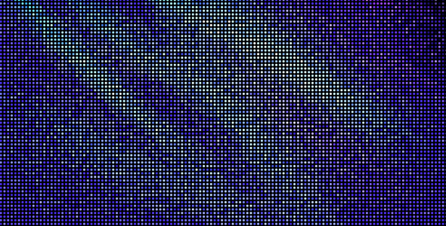 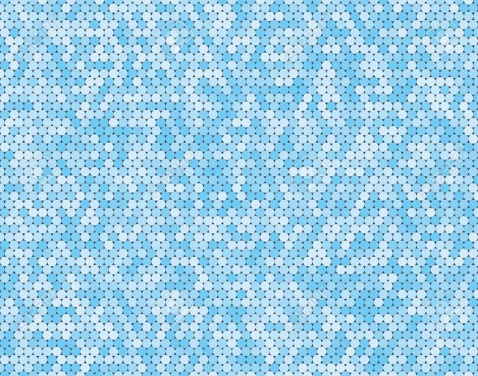

So, using a jellyfish shape as inspiration:

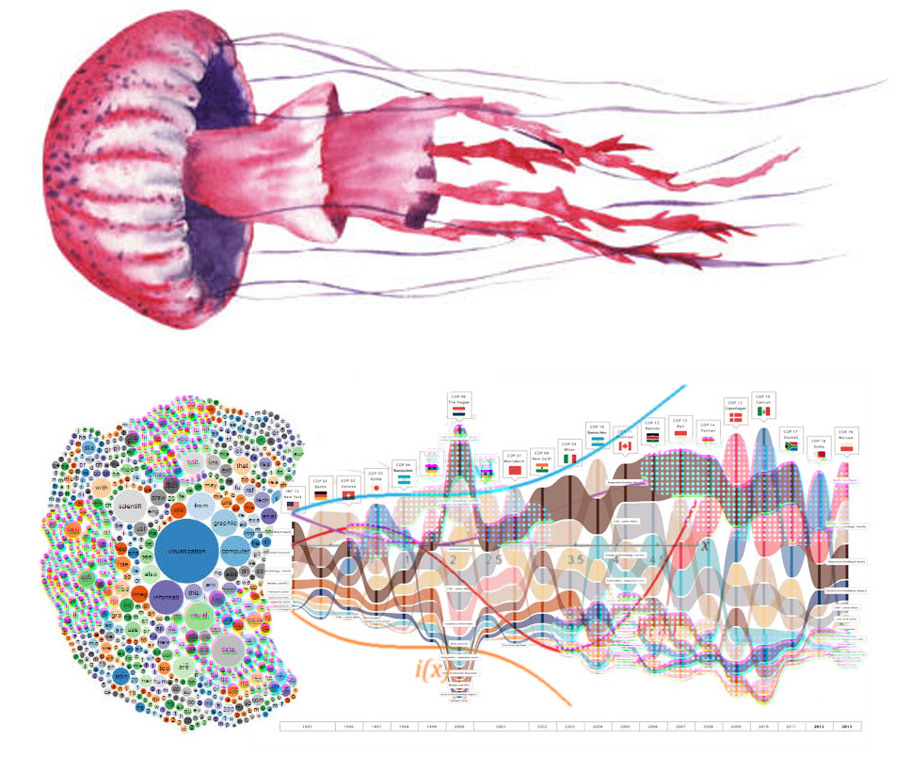

I put together this mock up of a visualization:

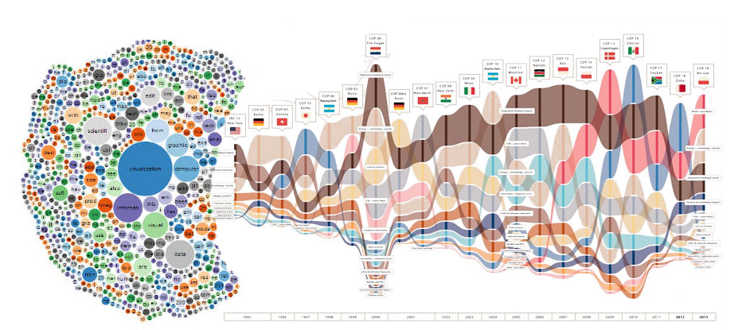

Then I tried adding some chromatic aberration to parts of the graph (with dot texture added):

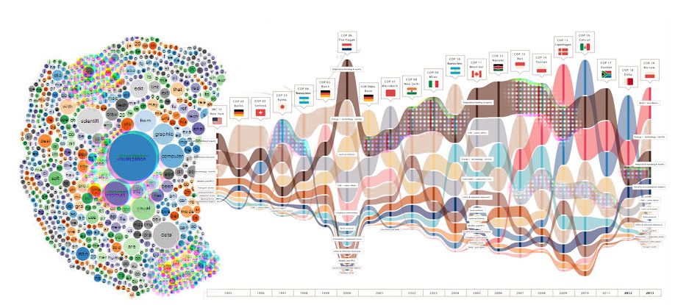

This is where I added it:

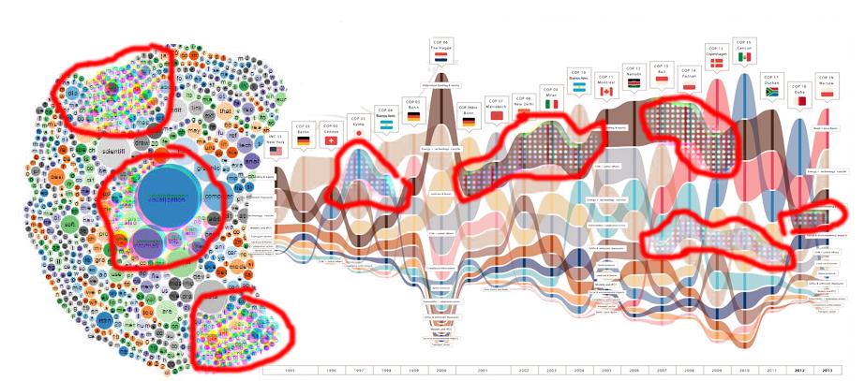

Comments:

* Chromatic aberration should not be applied to the text labels.
* It may be necessary to only have the chromatic aberration visible when you zoom in?
* The addition of a simple LCD pixel-like texture of dots may be needed to effectively see the chromatic aberration in some types of visualization and at some scales.

Another design inspired by starfish/jellyfish:

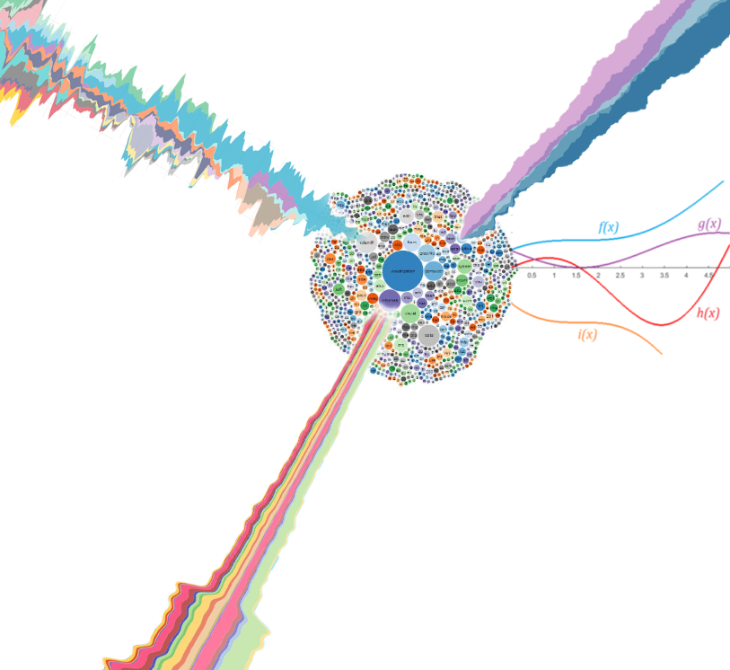

The idea with this one is the bubble chart would be the primary visualization with each bubble being a country. But the user can select a country in the bubble chart and that spawns a steams graph out radially from that selected bubble. The curves on the right side might be global curves for all countries and they might reposition into empty space, radially. The stream graphs have a white glow around them to make them stand out better from the bubble chart.

And this is another attempt to apply a circular pixel texture and some chromatic aberration to a stream graph:

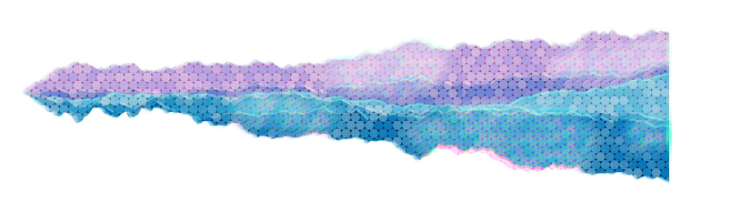

BTW, all these mock-ups were done in Adobe Photoshop, not coded in D3.

Related work:

* Starfish Diagrams, <https://www.sciencedirect.com/science/article/pii/S2213133715000086>
* Jellyfish graphs, from graph theory, <https://www.researchgate.net/figure/The-jellyfish-graph-B-Bk-dn-r-mTH_fig1_310767573>
* sorted stream graphs, <https://datavizproject.com/data-type/sorted-stream-graph/>